**Exercise1: Configure data sources**

**Step1**: Load the sales data:

1. Load the **Tailwind Traders Sales** file into Power BI.
2. Check attributes data types, missing or Null values and duplicates rows.

To identify data anomalies, outliers, distributions within dataset we apply data profiling tools.

1. To detect empty and invalid values in **order_id** column we can just select column quality in **data preview** group in **view** tab. I found that 100% of the values are **Valid**, 0% of the values are **Error** and 0% of the values are **Empty** rows in the **Order_id** column.

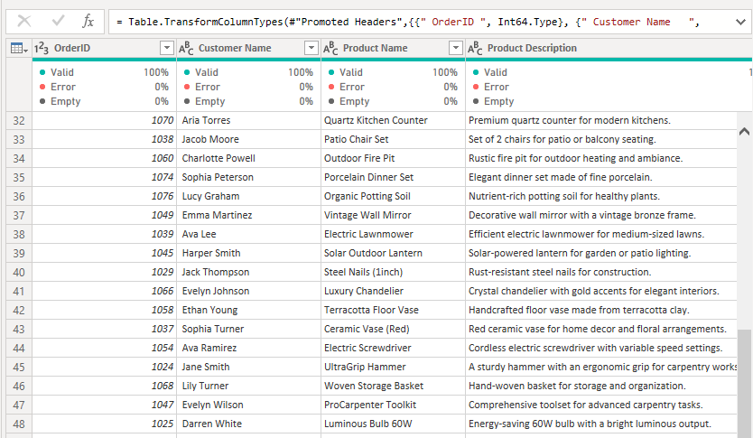

1. To examine the frequency of distinct and unique values of **Gross Product Price** column we select **column distribution** in the same group as the previous question. As you can see, we have 50 distinct & 46 unique values. Which means there are 4 products with the same price.

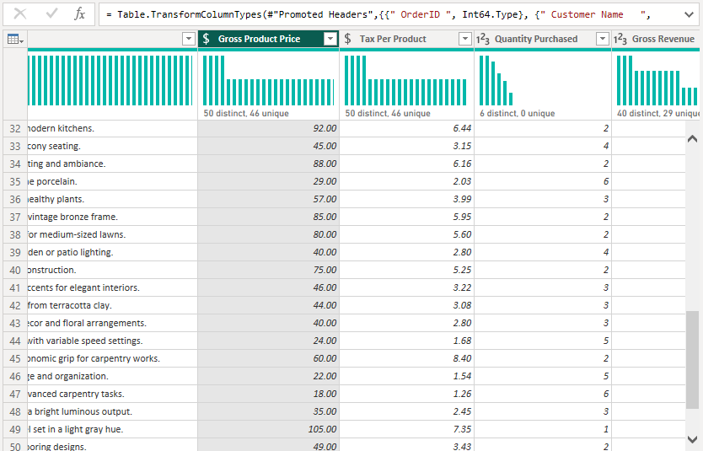

1. Note that **min** value is 1, **max** value is 6, and **average** is 2.81 for the **Quantity Purchased** column.

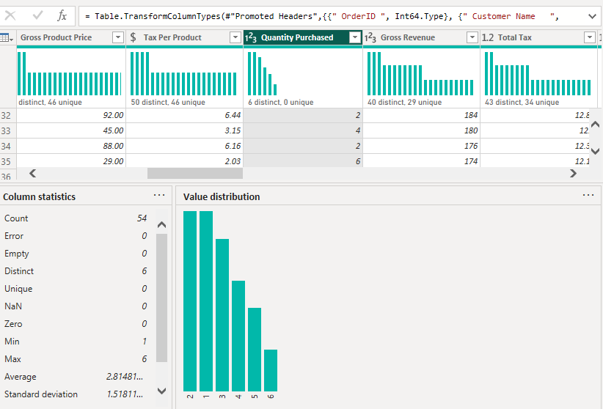

**Step 2: Load the purchased data:**

1. Load purchases file to power bi
2. Adjust data types of attributes.
3. **min** value is 6, **max** value is 48, and **average** is 18,88 for the **warranty** column.

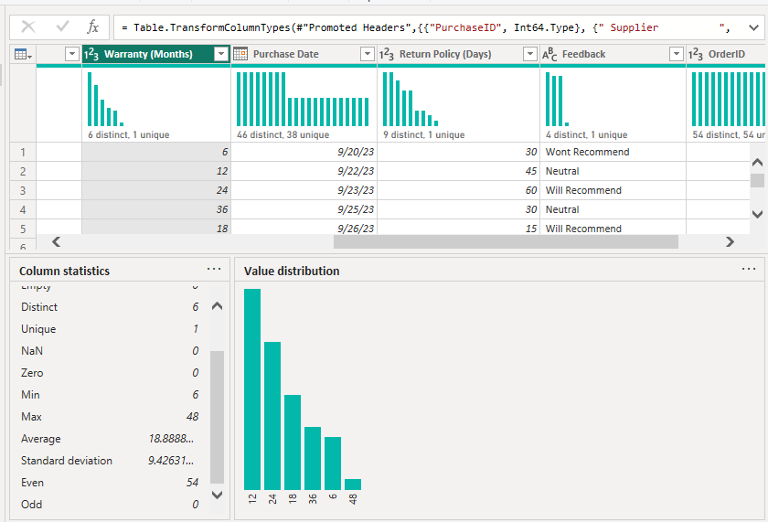

1. I found that 100% of the values are **Valid** in the **return status** column.

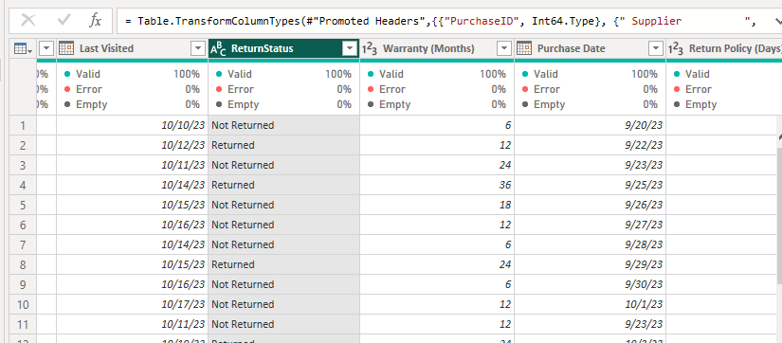

**Step 3:** Load the Countries data:

The same process as the previous steps.

**Step 4:** Load the historical currency exchange data.

**Exercise2: Design and develop the data model:**

**step 1:** Create a relationship between the Countries and Exchange Data tables

I Set the **Cardinality** to **One to One (1:1), As well** the **Cross-filter direction** to **Both** to be bi-directional. Make sure the **Make this relationship active** checkbox is selected.

**Step2:** Create a relationship between the Sales and Countries tables

**Step3:** Create a relationship between the Purchases and Sales tables

**Step4:** Configure the Calendar table: Create a new **Calendar** table using DAX

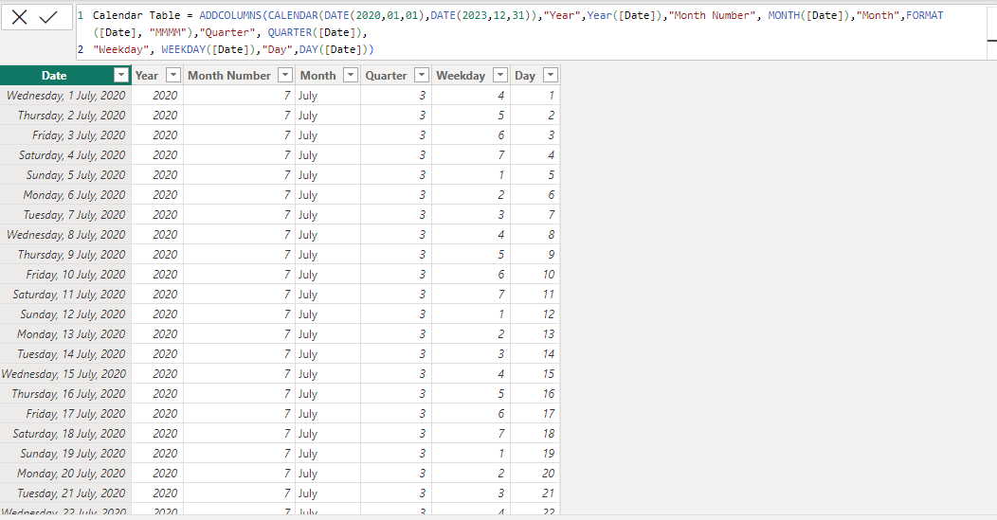

**Step 5:** Create a relationship between the Calendar and Purchases tables

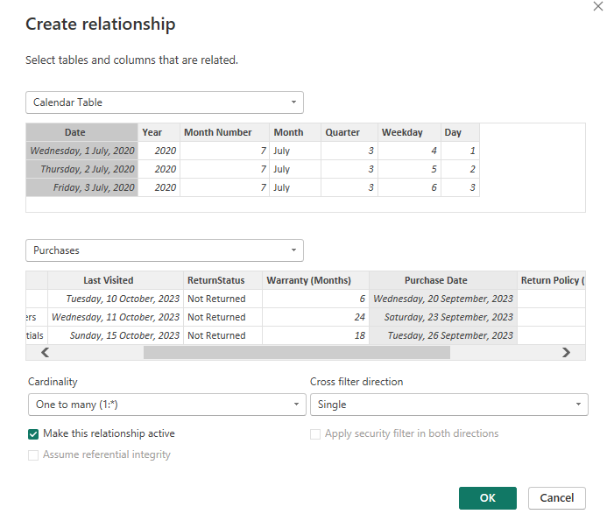

Step 6: Create a Sales in USD calculated table.

Since the sales data contains sales for different countries that means different currencies so in this step, I had to convert all the currencies to **USD**.

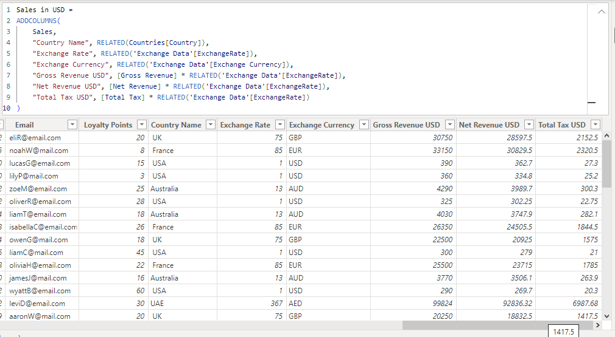

Step 7: Create a relationship between the Sales in USD and Sales tables

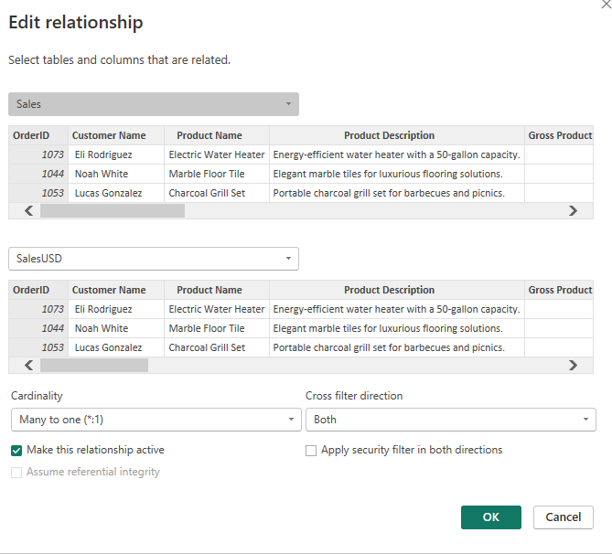

Final data model

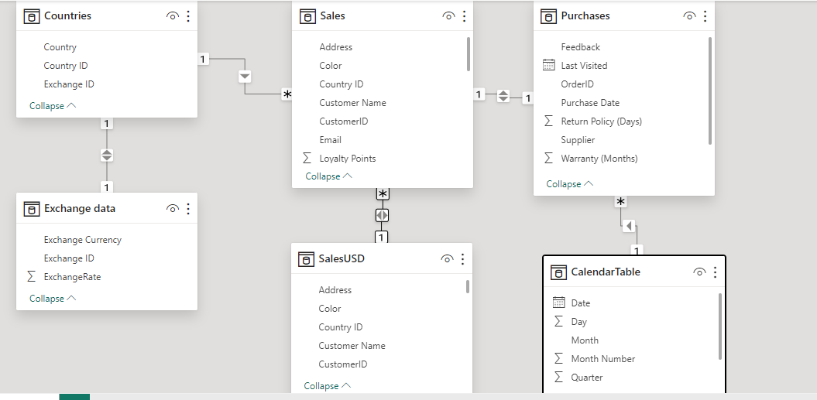

 Summary:

**Tailwind Traders Project:**

* Obtained data using MS Excel and cleaned, transformed, loaded data in Power bi.
* Examined Data Accuracy & Quality using data profiling tools.
* Designed a data model, created model calculations using DAX and optimized model performance.
* Build 2 detailed reports describing the company's latest sales and profit.
* Generated insights from the data.
* Created an executive dashboard.
* Configured an alert on a KPI to receive notification whenever Gross revenue USD drop below 400$.
* Set Up subscriptions to empower stakeholders with timely and actionable insights.